DMCAAS-8616

8664-2 As an IQC user, I see new Site of Service Setting on Review Summary PDF

**Preparation**

**SOS Benchmark data loader**

* Download the ZIP CSV file <https://jira.healthcareit.net/secure/attachment/2931733/SOS%20Load%20File%20v4.csv>
* Load SOS CSV File to End point /siteofservices

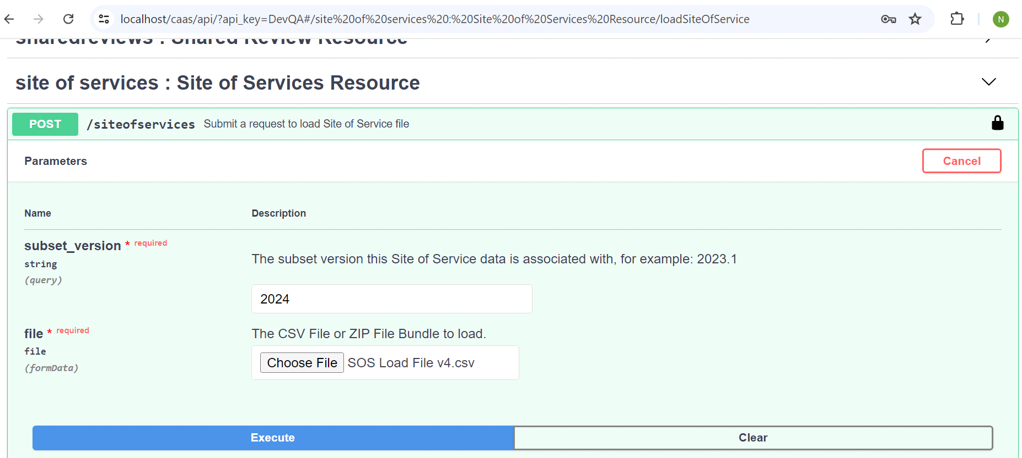

**Enable SOS Medicare Procedure and Care Procedure**

* Execute SQL statement to enable products, Medicare Procedures (MDCR-PROCEDURES) and CP: Procedures('PROCEDURES'), BH: Procedure Q&A(BHPROCEDURES)
* -- Insert SoSSource regarding 'BHPROCEDURES','PROCEDURES' and 'MDCR-PROCEDURES'

INSERT INTO SUBSET_PROPERTY (SUBSET_PROPERTY_ID, SUBSET_ID, NAME, DESCRIPTION, VALUE, DATA_TYPE)

* SELECT SUBSET_PROPERTY_SEQ.nextval, smv.LATEST_REVISION_SUBSET_ID, 'SoSSource', 'SoS Source', 'CMS', 'string'
* FROM SUBSET_MINOR_VERSION smv
* JOIN CATEGORY_SUBSET_IDENT_ASSOC csia ON smv.SUBSET_IDENTIFIER_ID = csia.SUBSET_IDENTIFIER_ID
* JOIN CATEGORY c ON csia.CATEGORY_ID = c.CATEGORY_ID
* JOIN PRODUCT_VERSION pv ON c.PRODUCT_VERSION_ID = pv.PRODUCT_VERSION_ID
* JOIN PRODUCT p ON pv.PRODUCT_ID = p.PRODUCT_ID
* WHERE smv.ACTIVE = 1
* -- AND p.PRODUCT_CID = 'MDCR-PROCEDURES'
* -- AND p.PRODUCT_CID = 'BHPROCEDURES'
* AND p.PRODUCT_CID = 'PROCEDURES'
* AND pv.VERSION_CID = 'RM24';
* -- Insert SoSAge regarding 'BHPROCEDURES','PROCEDURES' and 'MDCR-PROCEDURES'
* INSERT INTO SUBSET_PROPERTY (SUBSET_PROPERTY_ID, SUBSET_ID, NAME, DESCRIPTION, VALUE, DATA_TYPE)
* SELECT SUBSET_PROPERTY_SEQ.nextval, smv.LATEST_REVISION_SUBSET_ID, 'SoSAge', 'SoS Age', 'ADULT', 'string'
* FROM SUBSET_MINOR_VERSION smv
* JOIN CATEGORY_SUBSET_IDENT_ASSOC csia ON smv.SUBSET_IDENTIFIER_ID = csia.SUBSET_IDENTIFIER_ID
* JOIN CATEGORY c ON csia.CATEGORY_ID = c.CATEGORY_ID
* JOIN PRODUCT_VERSION pv ON c.PRODUCT_VERSION_ID = pv.PRODUCT_VERSION_ID
* JOIN PRODUCT p ON pv.PRODUCT_ID = p.PRODUCT_ID
* WHERE smv.ACTIVE = 1
* -- AND p.PRODUCT_CID = 'MDCR-PROCEDURES'
* -- AND p.PRODUCT_CID = 'BHPROCEDURES'
* AND p.PRODUCT_CID = 'PROCEDURES'
* AND pv.VERSION_CID = 'RM24';
* -- Update SoSLookup regarding 'BHPROCEDURES','PROCEDURES' and 'MDCR-PROCEDURES'
* update subset_property
* set value='true'
* where name = 'SoSLookup'
* and subset_id in
* (select smv.LATEST_REVISION_SUBSET_ID FROM SUBSET_MINOR_VERSION smv
* JOIN CATEGORY_SUBSET_IDENT_ASSOC csia ON smv.SUBSET_IDENTIFIER_ID = csia.SUBSET_IDENTIFIER_ID
* JOIN CATEGORY c ON csia.CATEGORY_ID = c.CATEGORY_ID
* JOIN PRODUCT_VERSION pv ON c.PRODUCT_VERSION_ID = pv.PRODUCT_VERSION_ID
* JOIN PRODUCT p ON pv.PRODUCT_ID = p.PRODUCT_ID
* WHERE smv.ACTIVE = 1
* -- AND p.PRODUCT_CID = 'MDCR-PROCEDURES'  
  -- AND p.PRODUCT_CID = 'BHPROCEDURES'
* AND p.PRODUCT_CID = 'PROCEDURES'  
  AND pv.VERSION_CID = 'RM24');
* Using the SQL below to check Whether the setting is well-configured
* Select *
* from SUBSET_PROPERTY where name in ('SoSSource','SoSAge','SoSLookup')
* and subset_id in
* (select smv.LATEST_REVISION_SUBSET_ID FROM SUBSET_MINOR_VERSION smv
* JOIN CATEGORY_SUBSET_IDENT_ASSOC csia ON smv.SUBSET_IDENTIFIER_ID = csia.SUBSET_IDENTIFIER_ID
* JOIN CATEGORY c ON csia.CATEGORY_ID = c.CATEGORY_ID
* JOIN PRODUCT_VERSION pv ON c.PRODUCT_VERSION_ID = pv.PRODUCT_VERSION_ID
* JOIN PRODUCT p ON pv.PRODUCT_ID = p.PRODUCT_ID
* WHERE smv.ACTIVE = 1
* -- AND p.PRODUCT_CID = 'PROCEDURES'
* -- AND p.PRODUCT_CID = 'BHPROCEDURES'
* AND p.PRODUCT_CID = 'MDCR-PROCEDURES'
* AND pv.VERSION_CID = 'RM24')
* order by SUBSET_PROPERTY_ID desc;

**AC1: Document display of Site of Service data for IQ Benchmark SoS on the Review Summary PDF: CP: Procedures or BH: Services products only**

* Product: CP: Procedures or BH: Procedures Q&A
* Version: 2024
* Subset: Transcranial Magnetic Stimulation (TMS)
* Select CPTs on Recommendations which results in an IQ Benchmark SoS Setting
* Result:   
  Review Level shows SoS setting (No Setting Determined) and possible LTD flag from Sos Setting,  
  Recommendation Service level shows Benchmark Setting including LTD flag and Source (IQ) with Age Range.

**AC2: Document display of Site of Service data for CMS Benchmark SoS on the Review Summary PDF: Medicare: Procedures**

* Product: Medicare: Procedures
* Version: 2024
* Subset: Transcranial Magnetic Stimulation (TMS)
* Select CPTs on Recommendations which results in an IQ Benchmark SoS Setting
* Expected Result:   
  Review Level shows SoS setting (No CMS Setting Determined) and possible LTD flag from Sos Setting,  
  Recommendation Service level shows Benchmark Setting including LTD flag and Source (CMS) with No Age Range